**Virtual Reality English Tours: An Innovative Approach to Language Learning”**  
  
 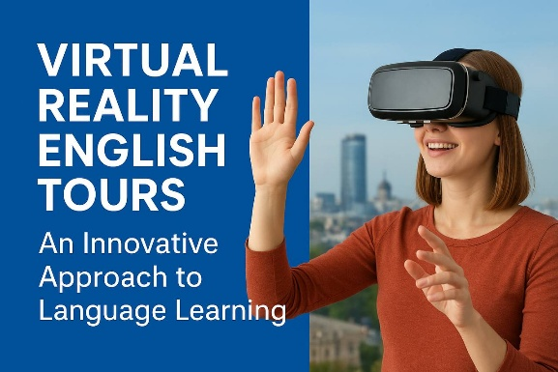In the 21st century, English has become not only a tool of communication but also a gateway to knowledge, collaboration, and innovation. Traditional methods like grammar drills and textbook reading are no longer sufficient. To meet today’s needs, the **“Virtual Reality English Tours”** course was designed, offering a modern and technology-driven approach to language learning.  
 To improve English proficiency and cultural awareness by immersing learners in virtual reality environments that simulate authentic communication.  
The learning experience aims to expose students to natural and conversational English, while also developing their listening, speaking, reading, and writing skills through interactive tasks. It encourages intercultural understanding and empathy, fosters creativity through blogs, vlogs, and digital storytelling, and strengthens students’ digital literacy and ability to express themselves clearly.  
 By the end of the program, students will be able to navigate virtual reality environments using English instructions and confidently use vocabulary related to travel, city life, directions, and social interaction. They will demonstrate progress in pronunciation, fluency, and spontaneous conversation, as well as create blogs, vlogs, and scripts based on their VR experiences. In addition, learners will apply their knowledge of cultural practices in English-speaking contexts and collaborate with peers to design a unique virtual tour project.  
 The learning experience uses a variety of engaging methods, including virtual tours where students visit landmarks and complete language tasks, and role-plays that allow them to practice real-life exchanges such as shopping or asking for directions. Students also write blogs and create vlogs to reflect on their weekly experiences, work on collaborative projects with peer feedback, and prepare for active learning through flipped classroom activities with pre-class videos and readings.  
 Feedback process is both formative and summative. Formative assessment includes participation in class activities, teacher observation, and feedback on blogs and speaking tasks. Summative assessment consists of a final “Virtual Tour Expo” where students present their projects, oral presentations evaluated with rubrics, a writing portfolio containing selected work, and structured peer and self-assessment.  
 **In conclusion,** unlike traditional courses, this program turns learners into **active participants** who explore, interact, and create in English. It develops not only language skills but also 21st-century competencies such as communication, collaboration, and cultural empathy.  
**“Virtual Reality English Tours” is more than a course—it is an invitation to discover the world through English and to connect with global cultures in creative, meaningful ways.**